Watching YouTube videos in PowerPoint with Internet Connection:

- Start PowerPoint
- Open the PowerPoint presentation you want the YouTube video in
- Insert a new blank slide
- Right-click on the existing toolbars and choose the Control Toolbox toolbar
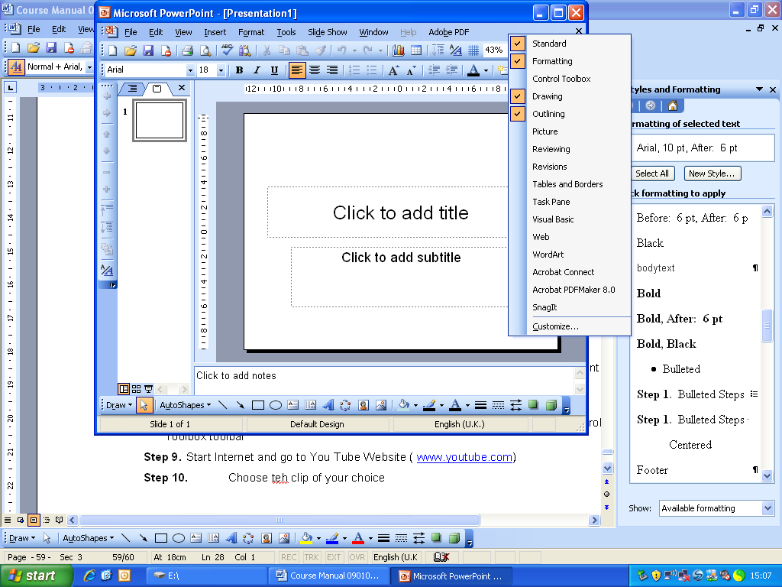

- Click on the More Controls button 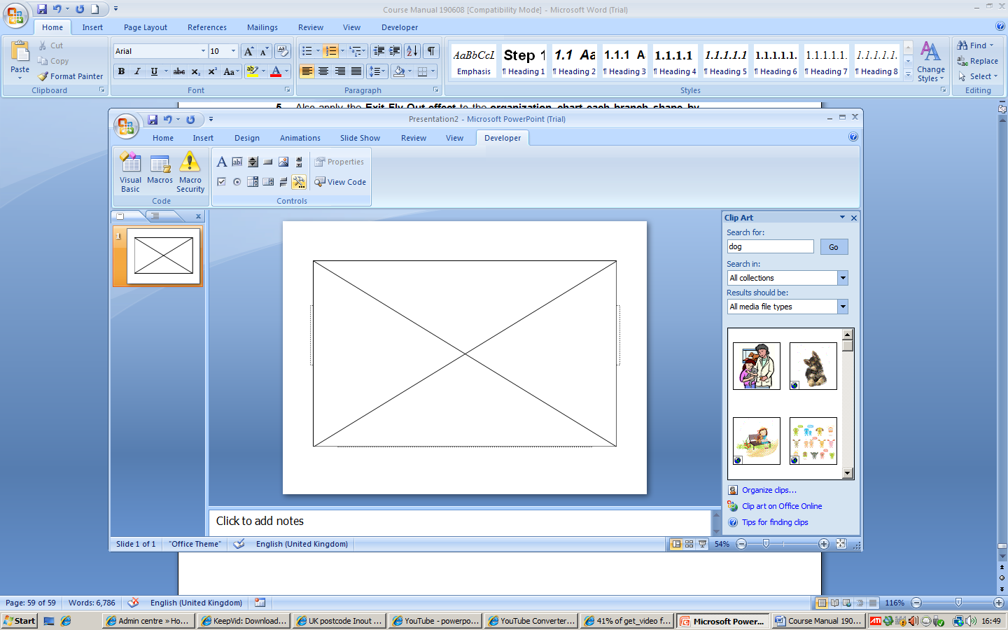 (Hammer and the Spanner)

- From the drop down list select Shockwave Flash Object
- On the blank slide drag your mouse and create a rectangle to the size you want the video clip to be
- Keep the object selected and click on the Properties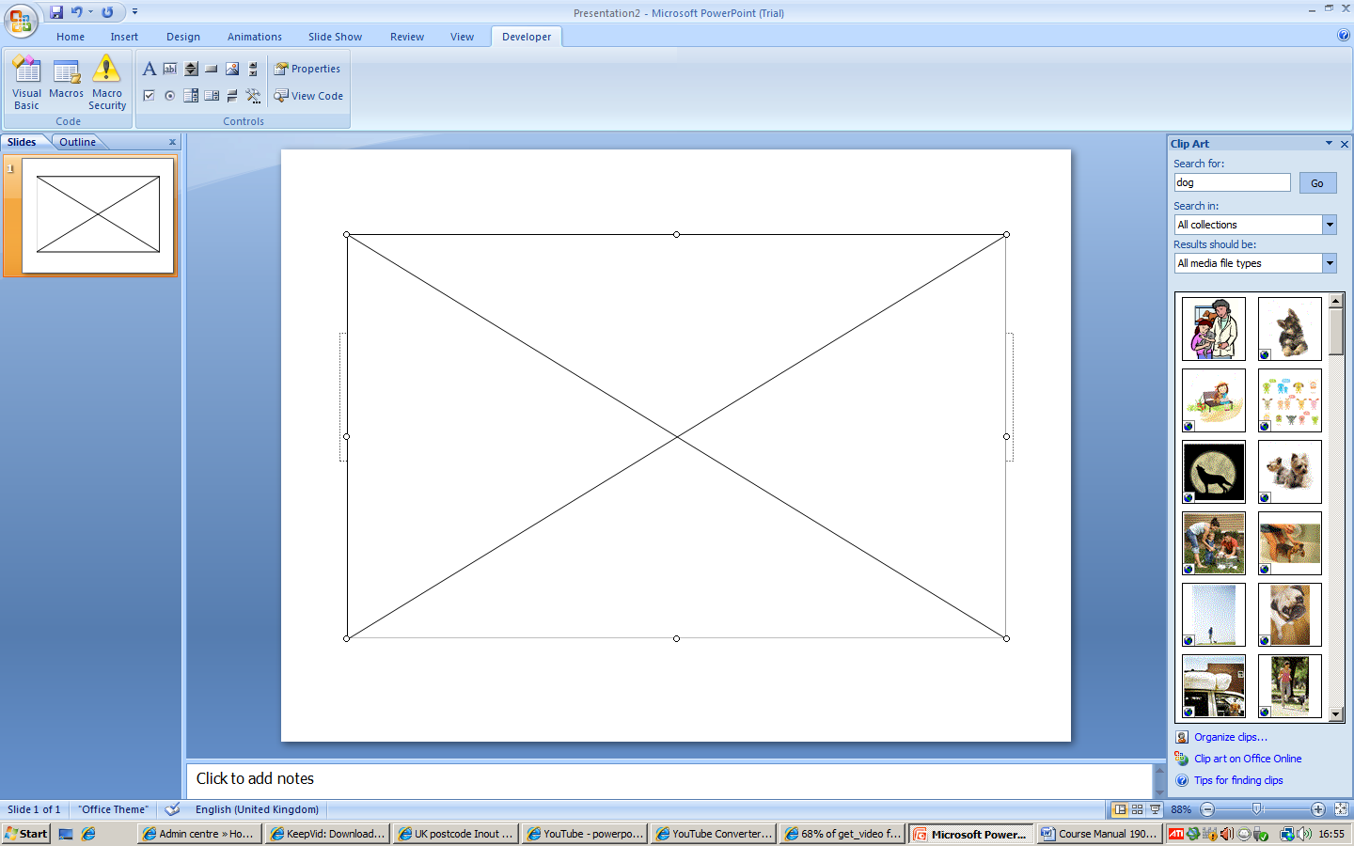 button on the Control Toolbox toolbar
- Start Internet and go to You Tube Website ( www.youtube.com)
- Type the key word and then press Search button. Choose the clip of your choice
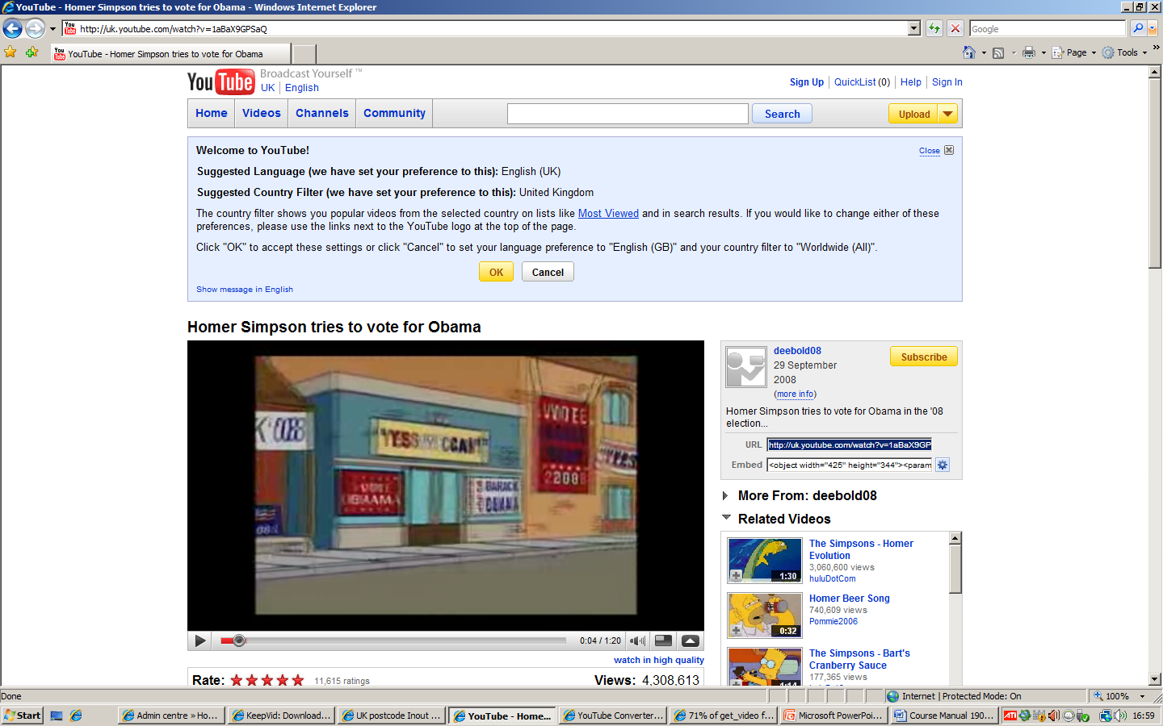
- On the right hand side you will see URL section
- Copy (Ctrl + C) the URL
- Go back to PowerPoint and on the properties box locate the Movie
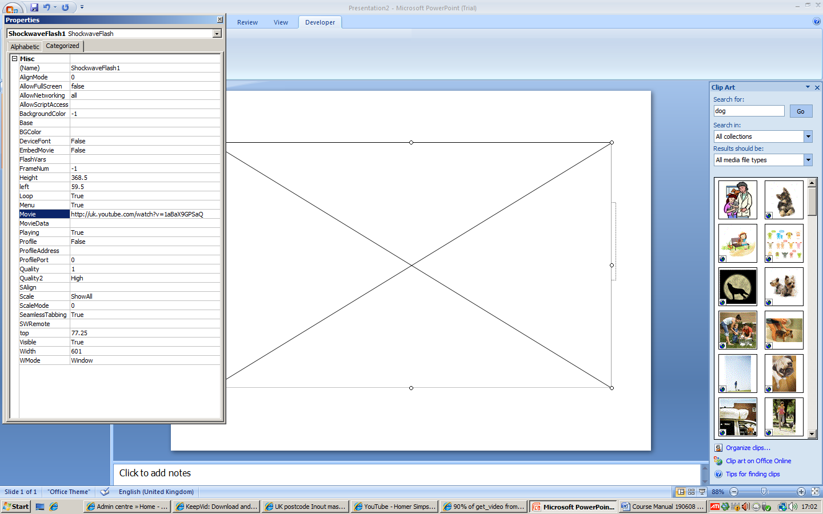
- Paste (Ctrl +V) the link in this box
- There are some adjustments that you need to do before you can view the clip and they are as follows:
  - Select watch? and delete it
  - Select = and replace it by /
- Close the properties dialog box
- View the Slide show and you should be able to click on the play button to view the clip.

